**Q** . Calculated interest based on type of account and status of account holder .The rate of interest changes to the amount(greater then 1 crore ),age of account holder(general or senior citizen) and of days if the type account FD and RD.

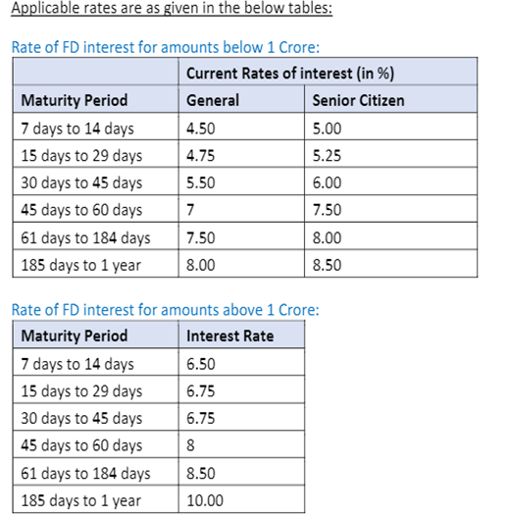

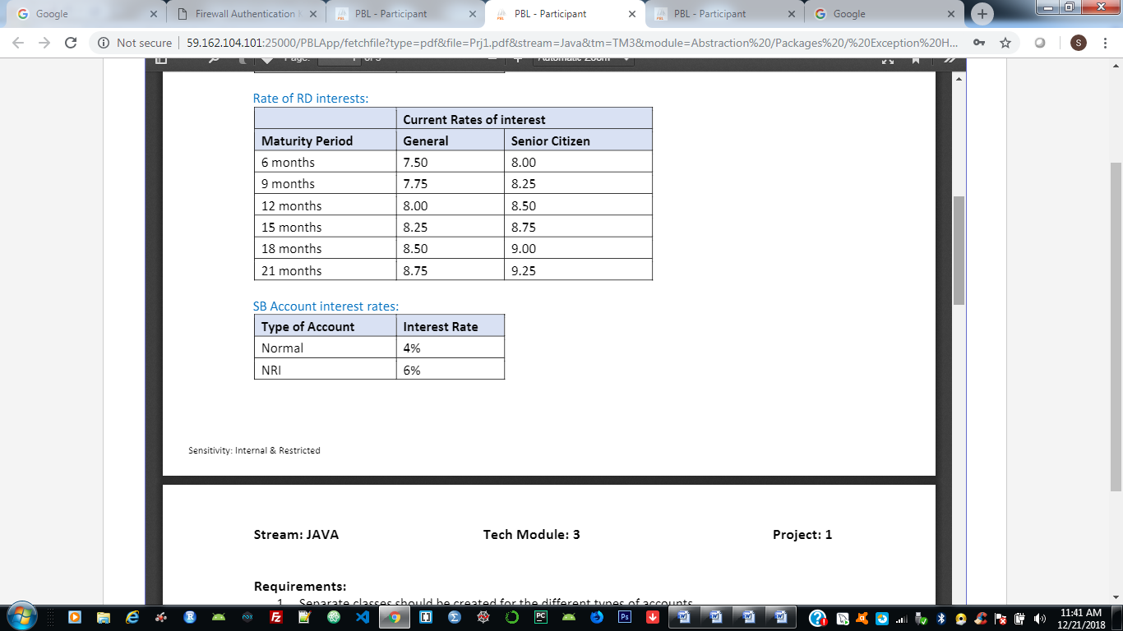

Answere:

import java.util.*;

abstract class Account{

double interestRate;

double amount;

abstract double calculateinterest();

}

class FDAccount extends Account{

double interestRate;

double amount,net;

int no_of_days;

int age_of_Acholder;

FDAccount(double amount1,int days,int age){

amount=amount1;

no_of_days=days;

age_of_Acholder=age;

}

double calculateinterest(){

if(amount>100000000) {

if( no_of_days>=7 && no_of_days<=14) {

interestRate = amount*6.5/100;

System.*out*.println("interest gained : Rs."+ interestRate);

}

else if( no_of_days>=15 && no_of_days<=29) {

interestRate = amount*6.75/100;

System.*out*.println("interest gained : Rs."+ interestRate);

}

else if( no_of_days>=30 && no_of_days<=45) {

interestRate = amount*6.75/100;

System.*out*.println("interest gained : Rs."+ interestRate);

}

else if( no_of_days>45 && no_of_days<=60) {

interestRate = amount*8/100;

System.*out*.println("interest gained : Rs."+ interestRate);

}

else if( no_of_days>=61 && no_of_days<=184) {

interestRate = amount*8.5/100;

System.*out*.println("interest gained : Rs."+ interestRate);

}

else if( no_of_days>=185 && no_of_days<=365) {

interestRate = amount*10/100;

System.*out*.println("interest gained : Rs."+ interestRate);

}

}

else {

if(age_of_Acholder<60) {

if( no_of_days>=1 && no_of_days<=14) {

interestRate = amount*4.5/100;

System.*out*.println("interest gained : Rs."+ interestRate);

}

else if( no_of_days>=15 && no_of_days<=29) {

interestRate = amount*4.75/100;

System.*out*.println("interest gained : Rs."+ interestRate);

}

else if( no_of_days>=30 && no_of_days<=45) {

interestRate = amount*7/100;

System.*out*.println("interest gained : Rs."+ interestRate);

}

else if( no_of_days>45 && no_of_days<=60) {

interestRate = amount*7.5/100;

System.*out*.println("interest gained : Rs."+ interestRate);

}

else if( no_of_days>=61 && no_of_days<=184) {

interestRate = amount*8/100;

System.*out*.println("interest gained : Rs."+ interestRate);

}

else if( no_of_days>=185 && no_of_days<=365) {

interestRate = amount* 4.5/100;

System.*out*.println("interest gained : Rs."+ interestRate);

}

}

else {

if( no_of_days>=1 && no_of_days<=14) {

interestRate = amount*1 + 5.0/100;

System.*out*.println("interest gained : Rs."+ interestRate);

}

else if( no_of_days>=15 && no_of_days<=29) {

interestRate= amount* 5.25/100;

System.*out*.println("interest gained : Rs."+ interestRate);

}

else if( no_of_days>=30 && no_of_days<=45) {

interestRate = amount*1 + 6.00/100;

System.*out*.println("interest gained : Rs."+ interestRate);

}

else if( no_of_days>45 && no_of_days<=60) {

interestRate = amount*7.50/100;

System.*out*.println("interest gained : Rs."+ interestRate);

}

else if( no_of_days>=61 && no_of_days<=184) {

interestRate = amount*8/100;

System.*out*.println("interest gained : Rs."+ interestRate);

}

else if( no_of_days>=185 && no_of_days<=365) {

interestRate = amount*8.5/100;

System.*out*.println("interest gained : Rs."+ interestRate);

}

else {

System.*out*.println("Invalid number of days. please enter non-negative values.");

}

}

}

return 0 ;

}

}

class RDAccount {

RDAccount(Double amount1,int months ,int age)

{

amount=amount1;

no_of_month=months;

age_of_ACholder=age;

}

double interestRate;

double amount;

int no_of_days;

int age_of_ACholder;

double MonthlyAmount;

double calculateinterest() {

if(age_of_ACholder<60) {

if( no_of_month>=1 && no_of_month<=6) {

interestRate = amount*7.5/100;

System.*out*.println("interest gained : Rs."+ interestRate);

}

else if( no_of_months>6 && no_of_months<=12) {

interestRate = amount*7.75/100;

System.*out*.println("interest gained : Rs."+ interestRate);

}

else if( no_of_month>12 && no_of_month<=15) {

interestRate = amount*8/100;

System.*out*.println("interest gained : Rs."+ interestRate);

}

else if( no_of_month>15 && no_of_month<=18) {

interestRate = amount*8.25/100;

System.*out*.println("interest gained : Rs."+ interestRate);

}

else if( no_of_month>18 && no_of_month<=21) {

interestRate = amount*8.75/100;

System.*out*.println("interest gained : Rs."+ interestRate);

}

}

else {

if( no_of_month>=1 && no_of_month<=6) {

interestRate = amount*1 + 8.0/100;

System.*out*.println("interest gained : Rs."+ interestRate);

}

else if( no_of_month>6 && no_of_month<=12) {

interestRate= amount* 8.25/100;

System.*out*.println("interest gained : Rs."+ interestRate);

}

else if( no_of_month>12 && no_of_month<=15) {

interestRate = amount* + 8.5/100;

System.*out*.println("interest gained : Rs."+ interestRate);

}

else if( no_of_month>15 && no_of_months<=18) {

interestRate = amount*8.75/100;

System.*out*.println("interest gained : Rs."+ interestRate);

}

else if( no_of_month>18 && no_of_month<=21) {

interestRate = amount*9/100;

System.*out*.println("interest gained : Rs."+ interestRate);

}

else if( no_of_month>=185 && no_of_month<=365) {

interestRate = amount*9.25/100;

System.*out*.println("interest gained : Rs."+ interestRate);

}

else {

System.*out*.println("Invalid number of days. please enter non-negative values.");

}

}

return 0 ;

}

}

class SBAccount extends RDAccount{

SBAccount(Double amount1, int days, int age) {

super(amount1, days, age);

// TODO Auto-generated constructor stub

}

SBAccount(){

this(0.00,0,0);

}

double interestRate;

double amount;

double calculateinterest(String user,double amount ) {

if(user.equals("normal")) {

interestRate=4;

double total=amount*interestRate/100;

System.*out*.println("Interest gained is RS.:"+total);

}

else if(user.contentEquals("NRI")) {

interestRate=6;

double total=amount*interestRate/100;

System.*out*.println("Interest gained is RS.:"+total);

}

return 0 ;

}

}

public class main extends SBAccount {

public static void main(String[] args) {

// TODO Auto-generated method stub

Scanner s =new Scanner(System.*in*);

int n,days,age;

String user;

double amount;

char ch='y';

while(ch=='y') {

System.*out*.println("Main menu ");

System.*out*.println("-----------");

System.*out*.println("1.Interest calculator - SB \n 2. Interest calculator - FD \n 3.Interest calculator - RD \n 4.exit");

System.*out*.println("Enter your option :");

n=s.nextInt();

switch(n) {

case 1:

System.*out*.println("Enter the average amount: ");

amount=s.nextDouble();

System.*out*.println("enter the type of user :");

user=s.next();

SBAccount obj=new SBAccount();

obj.calculateinterest(user,amount);

break;

case 2:

System.*out*.println("Enter the FD_amount: ");

amount=s.nextDouble();

System.*out*.println("Enter the number of days : ");

days=s.nextInt();

System.*out*.println("Enter your age : ");

age=s.nextInt();

FDAccount obj1=new FDAccount( amount,days,age);

obj1.calculateinterest();

break;

case 3:

System.*out*.println("Enter the RD_amount: ");

amount=s.nextDouble();

System.*out*.println("Enter the number of month : ");

days=s.nextInt();

System.*out*.println("Enter your age : ");

age=s.nextInt();

RDAccount obj3=new RDAccount( amount,days,age);

obj3.calculateinterest();

break;

case 4:

break;

}

}

}

}

Output

